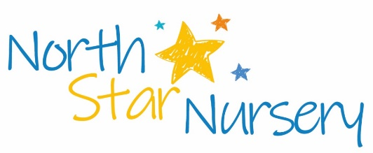
North Star Nursery Ltd- Recruitment
Currently recruiting for: -

- Maternity post -Level 3 Early Years Practitioner Full time (Monday to Friday on shift pattern between 8am and 6pm 38.75 hours per week)
22 days annual leave plus bank holidays and privilege days.

You must enjoy getting messy, be able to read a story using different voices, sing and dance through the day. Have excellent communication skills in both written and verbal format. Have and be able to demonstrate a sound knowledge of the Early Years Foundation Stage and plan for individual children’s needs with reference to Birth to five matters.
You will provide personal care for babies and young children, including: - feeding, nappy changes, toileting, administering medication, application of medicated creams, sun cream, sleep routines and cuddles.
North Star Nursery Ltd is committed to supporting the wellbeing and safeguarding of all children and young people in their care and expects all employees to have high regard for this throughout their working practice and personal ethos.

This post requires a Clear Enhanced DBS and suitable references prior to starting. Background checks and an enhanced DBS will be required.

This post is exempt from the Rehabilitation of Offenders Act 1974.

Initially one year pending any superseding events.
Full job description available upon request.
No C. Vs accepted, must request and submit application form for shortlisting via info@northstarnursery.co.uk

