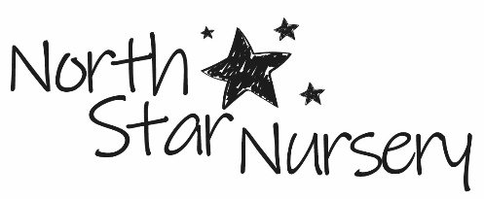

CHILD FRIENDLY PRIVACY NOTICE
Why do we keep information about you?
NORTH STAR NURSERY keep information about you so that we can give you the best possible care whilst you are here, keep you safe, help you to be happy and contact your parents or carers if we need to.

What information do we keep?
We only keep information about you that we really need.
We need to know things like your name, where you live and how to contact your parents or carers.
We also need to know about any health needs you may have or what foods you may or may not be able to eat.
Sometimes we may take photos of you to show your parents or that you can look at the next time you are here.

How do we collect information about you?
We ask your parents or carers for information about you as well as talking to you.

How do we use your information?
We use your information to get to know you so that we can look after you properly. We only share your information with people who NEED to know it to keep you safe.

Where do we keep your information?
Some of your information is kept on our computers and some is written down. We follow rules to make sure your information is kept safe and that it isn’t shared with anyone it shouldn’t be.

How long do we keep your information for?
After you stop coming to nursery or holiday club, we only keep your information for as long as the law says we need to.

Your rights
The law says you have a right to know what information we hold about you and that you can have a copy of this information. You should speak with your parent or carer if you wish to have this information.
You also have some other rights which you can talk to us about if you would like to.

North Star Nursery
01793 411994
info@northstarnursery.co.uk
February 2021

